Human Movement Science Department  Tel: 041 504 4884
Nelson Mandela Metropolitan University Fax: 041 504 2022
South Campus website: www.ecas.co.za
P O Box 77000
Port Elizabeth
6013

Dear Coaches!

What is your current leadership style, and is it effective? Are you aware that the culture and style of effective leadership are constantly evolving? As coaches, managers, and practitioners, we are all leaders in our own right. However, the unanswered questions remain; is your current leadership style bearing the fruits it deserves?

Mr. Paddy Upton, a leader in the sphere of sport psychology and performance delicately describes the paradigm shift in leadership styles that have taken place.

for a more comprehensive profile of Mr. Upton, please follow the link below: https://paddyupton.com/profile/

Follow the link below for a very informative video describing the shift in leadership styles titled:
THE LEADERSHIP TERRAIN IS CHANGING- Paddy Upton:
https://www.youtube.com/watch?v=LA-5i5icU6M&feature=youtu.be

Coaches, I urge you all to ADAPT your leadership style, EVOLVE & CONQUER.

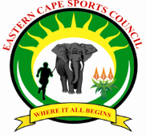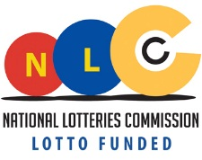
A program funded by National Lottery Distribution Trust Fund and the Department of Sport, Recreation, Arts and Culture (Eastern Cape)

